Date: December 12, 2024

Time: 3 – 4 p.m.

Microsoft Teams Meeting

Welcome & Roll Call

ITSS Operations Updates – Sri Kamarthi

- SSN Quarterly Verification — Quarterly verification for SSN’s are available in File Depot for the November 30th file.
  - Another verification will be done at the beginning of the year as a last check for W2's.

- SECC Deductions for 2025 will be loaded into Workday Production next week

- W-2 Year End Sandbox testing will begin 1st week in January

SECURE Act 2.0 – Sri Kamarthi

- Workday has automatically updated their table for limits to reflect the catch-up contribution limits to retirement plans for ages 60 to 63 — from $7,500 per year to $11,250 effective 1/1/2025.

- This has been verified by moving payroll forward to January.

- We will continue to monitor employees who will be meeting the new limits and verify deductions

New Earning Codes – Sri Kamarthi

- TAMU has requested a new earning code to pay 50% per Hour Shift Differential

- Employees will be getting this earning through time entry and submitting it for approval

- New Time Entry Code called TAMU Premium – Event will be setup to pay Paramedics x1.5 their hourly rate for eligible shifts worked. Only a certain employee population will be able to select the new time entry code based on the eligibility defined by TAMU.

Earning Code Name | Earning Code
50% per Hour Shift Differential | SD11

Off-cycle Pay Result Lines report – Scott Ritter

- TAMU has requested to add FICA OASDI & FICA MEDICARE Exemptions fields from the tax elections to the "Off-cycle Pay Result Lines" report
- These fields will help to research anyone with a FICA tax deduction but are exempt and vice versa

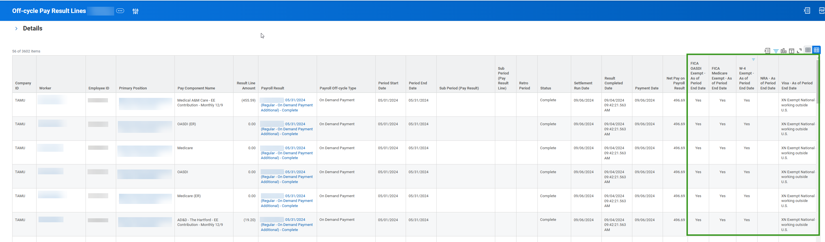

EIB Due Dates – Scott Ritter

Pay Date | Due Date for Completed EIB Template
December 13, 2024 | Thursday December 5, 2024
December 27, 2024 | Thursday December 12, 2024
January 10, 2025 | Thursday January 2, 2025
January 24, 2025 | Wednesday January 15, 2025
February 3, 2025 | Thursday January 16, 2025
February 7, 2025 | Thursday January 30, 2025

The minimum is close to 50 as possible

An authorized individual is the one submitting the Request for Mass Load (EIB) form on the Workday
Help Website

Please do not alter the formatting or add formulas to the spreadsheet

