Tuesday, June 24th , 2025
2:00 – 3:00 pm

Teams Meeting
Pamela Gentry; Julia Zimmerman; Sharvari Kulkarni

- Welcome & Roll Call

Name |  | Name |  | Name
Amber Cervantez TAMU, G, HSC | x | Jan Aspelund, TAMIU |  | Pam Young, WTAMU
Alissa Meyer, TAMUSA | x | Johnny Watson-Mendoza, TAMUT | x | Robin Elliott, TTI | x
Bettsy Hucker, TAMUCC |  | Joy Bading, AL & TVMDL | x | Sharissa Berry, ETAMU | x
Dawn Santo, TAMUS | x | Kristen Suehs, TFS (Melanie Karns) | x | Valerie Townsend, PVAMU | x
Derek Gonzales, TAMUK (& Yolonda Ballard) | x | Marissa Perez, TAMUCT (& Asia Terry) | x | Warren Pitt, WTAMU
Erica Wallingford, TEES | x | Melinda Ho, TDEM | x | Kristina Diaz, TEEX | x
Ivore Garza, Tarleton | x

- Voting Items:
- New Contingent Worker Type – Non-Affiliate Graduate Student
  - Will go to HAC
  - New corresponding Job Profile will be created
  - 15 Yes; 0 No

- Announcements:
  - Both of last month’s voting items passed (voting done via survey)
    - Contingent Worker optional fields – Going to HAC for vote
    - Report edits to Audit – Supervisory Organization Structure
  - Annual Disclosures
    - User Acceptance Testing for TTI & TAMUSA week of 7/15/25
  - New Staffing team member! Sharvari Kulkarni

- Discussion:
  - (TTI) New Change Job Template – Business Title & Comp Change
    - TAMU: Can it be opt in/out? - Don’t want accidental changes to salary instead of allowance
  - New report for personal information related changes
    - What personal info changes should be included in this report?
    - SSN Changes & Name Changes (Preferred vs Legal name changes, effective date of changes)
    - Drew: Anyone interested in preferred name?: Yes- TAMU, TDEM, TEES, TEEX, AG
    - PVAMU: Citizenship Status
    - TTI: Address Change (Work & Home, may not be able to include since this report is focused on personal info)
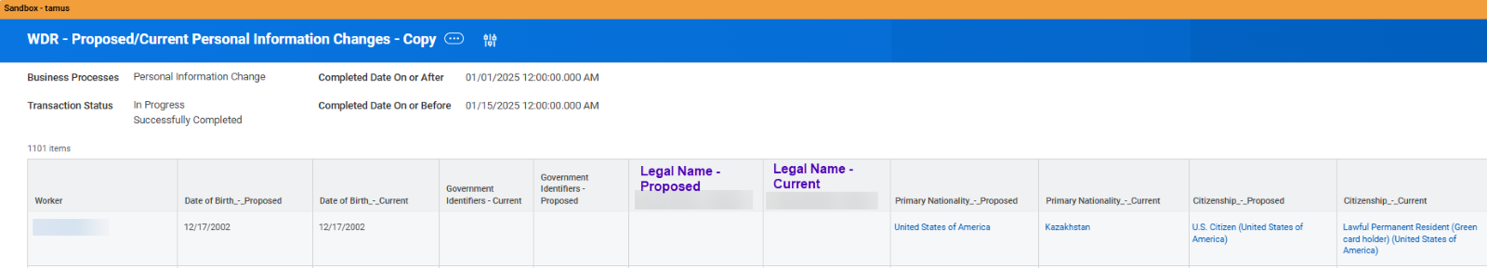
  - HR Partner view Offer Letter permissions
    - Currently, HR Partner can only view Offer Letter on the Employee Profile if they also have a recruiting role
    - PVAMU provided context on topic
    - Recruiting Partner View Only could be assigned
    - No Concerns from members to add permissions to HR Partner
  - (TEEX) New report for Create Position events
    - Would this be beneficial for other members?
    - Before next meeting – look at “Positions for HCM Executive Dashboard”
    - Would be helpful: PVAMU (for state reporting), TDEM
  - (System Academic Affairs) Academic Appointment approvals in Staffing processes
    - Should Academic Appointment approvals come before or after HR Approvals?
      - TARL: before HR
      - TAMU & TEES: Where did this request come from? Doesn’t see how this would work with Academic affairs current process
    - Working with Academic Affairs to remove paper process for higher level appointments. May result in additional steps being added to BPs like Hire, Add Job, Change Job.
    - To be discussed more next month & with more details
- Prior Action Items
  - WDS – Recommend solution for Vacation Payout in Termination BP
    - Still working on this

- Completed Changes
  - Onboarding Acknowledgement added for GA-48
  - Date of Birth required field in Personal Information Change
  - Additional Department Head Approval option added to Termination
  - Skip Manager Approval in End Flexible Work Arrangement
  - Optional Field Permissions in Hire
  - Military Status moved to Personal Information Change
  - Skip Manager Approval in Switch Primary Job
  - Org Chart Enhancement

- Upcoming Projects/Changes
  - TAMUV
  - New Template – Updating End Dates for Temp/Casual
  - New Change job Templates – ALL reasons, by March 2026 (WD R2)
  - Work and Home Contact forms – Separate
  - Automate Work Email Address – In discussion with CIOs
  - Visiting Scholar – Exploration for Workday as Record of Source
  - “Employment Disclosures” - Nepotism, Consensual Relationship, External Employment, Research Security – Exploration for Workday Solution
  - Academic Module – Exploration stage
  - Mass Action for Termination

- Old Items (Pending/On Hold)
  - Exit Survey Enhancements
  - Worker Documents and Purge
  - Due Dates – Consolidated list of current Due Dates to review
  - Mass Action for Change Job Templates – functionality not intuitive to assign to users

Next Meeting: July 29th

