Date: February 19, 2026

Time: 3 - 4 p.m.

Microsoft Teams Meeting

Operations Updates – Anna McCoy

W-2 Process
- W-2 process has completed.
- As a reminder, if there are any corrections or adjustments needed for employee W-2s, please submit a support request for a W-2C.
- Feedback is welcome and we always look for ways to improve the process

Payroll Calculation & Settlement Mornings
- Email if more time is needed for processing prior to 9AM
- Do not begin processing the next payroll period during the morning settlement window

Print Check Files
- Check files are automatically uploaded directly to Assurepay.
- Please submit a support ticket if you do not see your checks in Assurepay

WD2026R1 Updates

Withholding Orders for Employee Self Service – Anna McCoy

- Employees will be able to view active and historical Withholding Orders directly from their Worker Profile
- This would give them visibility into their own orders and reduce time fielding questions at HR and Payroll offices
- Employees will not be able to edit or make changes, updates will still require a support ticket submitted by your office.
- Must go through Governance approval process, if voted to proceed by Payroll Working Group. Will be voted during next meeting
- The Withholding Order for Worker report will now include the Total Debt Amount field, this will be available automatically.
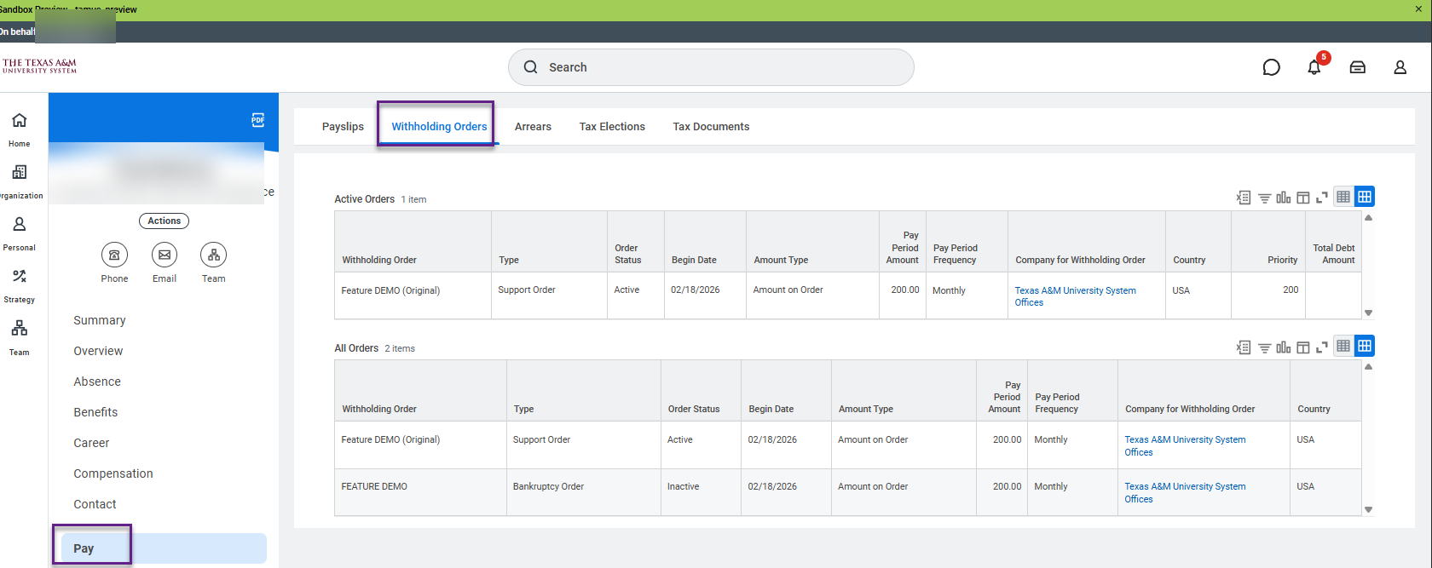

Reminder: Withholding orders submitted to the Service Desk, please include only the UIN in the support request subject line, and not the SSN for privacy and information security.

Pay Worklet on Workday Homepage to be deprecated – Sri Kamarthi

- Pay Worklet on Workday Homepage will be deprecated on March 14th with the 2026R1 release

- Employees should use Benefits and Pay hub for all the self-service activities

- Job aids and training materials on Workday help site will be updated to direct the employees towards Benefits and Pay hub

Costing Source – Sri Kamarthi

- A new field Costing Source is now available on the Actuals tab of the Payroll results providing a more streamlined approach to viewing and tracing assigned costing allocation data
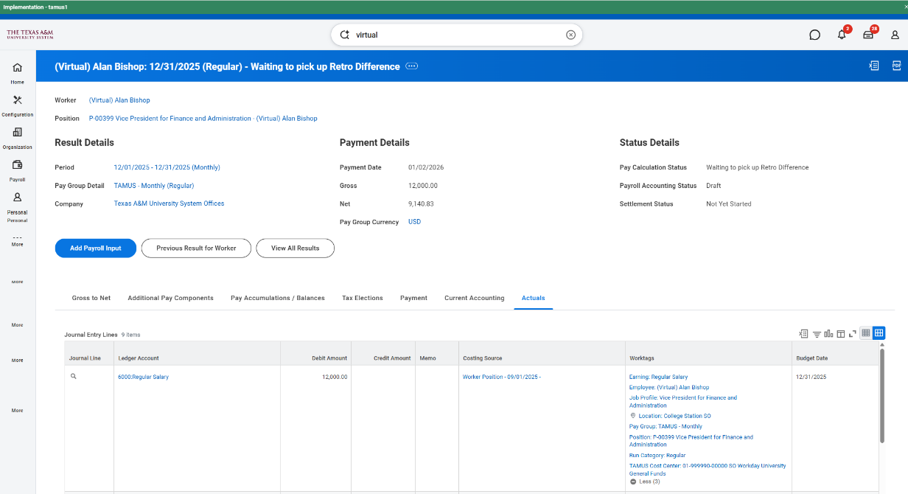

Bank Account Verification Display – Sri Kamarthi

- Bank Account Verification screen in the Payment Elections self-service flow now identifies the specific account using the account nickname or bank name, the account type, and the masked last 4 digits of the account number.
  - If an account nickname exists, we display: [Account Nickname] [Account Type] x [Last 4 Digits]
  - If no nickname exists, we display: [Bank Name] [Account Type] x[Last 4 Digits]

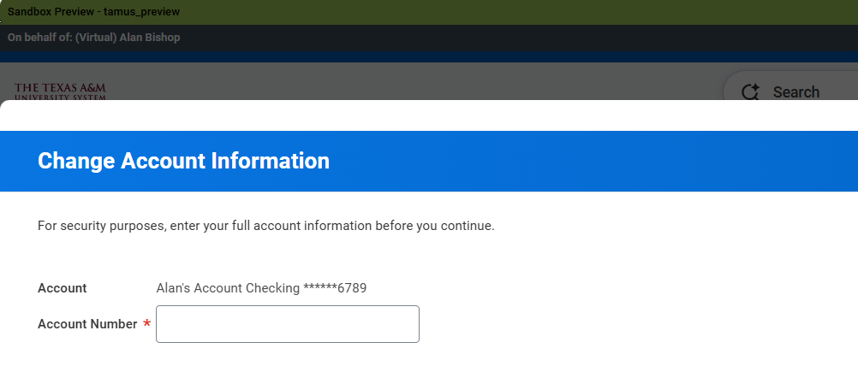

EIB Due Dates – Scott Ritter

Pay Date | Due Date for Completed EIB Template
March 6, 2026 | Thursday February 26, 2026
March 20, 2026 | Monday March 9, 2026
April 1, 2026 | Monday March 16, 2026
April 3, 2026 | Thursday March 26, 2026
April 17, 2026 | Thursday April 9, 2026

- The minimum is close to 50 as possible

- An authorized individual is the one submitting the Request for Mass Load (EIB) form on the Workday Help Website

- Please do not alter the formatting or add formulas to the spreadsheet

